**Artificial Intelligence and Machine Learning**

**Don't find customers for your product but find products for your customers**

**1. Team**

**Team Name:Team 13**

**Team Members:**

1. VARSHITHA REDDY- 2320040001
2. G.V.NAGA JAHNAVI YADAV- 2320040026
3. A. VAISHNAVI- 2320040130

**2. Problem/Opportunity Domain**

**Domain of Interest:**

The domain is AI-driven document processing, with a focus on both normal text data and tabular data extraction**.**

**Description of the Domain:**

This field deals with AI technologies that can process, extract, and display both structured (tabular) and unstructured (text) data from documents. The key challenges include accurately interpreting tables and complex document structures while also providing reliable answers to text-based queries**.**

**Why did you choose this domain?:**

The demand for AI solutions that can handle both normal text and tabular data is rapidly growing, especially as industries move towards digitizing large amounts of information. This project offers a solution to automate these processes, saving users time and improving accuracy.

**3. Problem/Opportunity Statement**

**Problem Statement:**

Users find it challenging to extract both normal text and tabular data from documents, leading to inefficiencies and errors in obtaining the information they need.

**Problem Description:**

Manually extracting and processing both textual and tabular data from documents is time-consuming and error-prone, especially when documents are lengthy or complex**.**

**Context (When does the problem occur):**

The problem occurs when users need specific text or tables from long reports, legal documents, or research papers.

**Alternatives (What does the customer do to fix the problem):**

Users manually copy text and tables or rely on basic search functions that may not be reliable for complex queries.

**Customers (Who has the problem most often):**

Researchers, data analysts, corporate professionals, and legal experts often face this problem.

**Emotional Impact (How does the customer feel):**

Customers are frustrated and feel that valuable time is wasted on manually searching through documents.

**Quantifiable Impact (What is the measurable impact):**

The time spent manually extracting data can range from hours to days, leading to delays in decision-making or reporting.

**Alternative Shortcomings (What are the disadvantages of the alternatives):**

Existing tools either focus on basic text extraction or table extraction but often struggle with handling both efficiently in the same document.

**4. Addressing SDGs**

**Relevant Sustainable Development Goals (SDGs):**

The project aligns with SDG 9: Industry, Innovation, and Infrastructure by advancing AI-driven solutions for document processing and SDG 8: Decent Work and Economic Growth by improving workplace productivity.

**How does your problem/opportunity address these SDGs?:**

Automating the extraction of both text and tabular data contributes to innovation and efficiency in industries, helping businesses and researchers manage information more effectively.

**5. Stakeholders**

Answer these below questions to understand the stakeholder related to your project

1. **Who are the key stakeholders involved in or affected by this project?**

**Primary stakeholders**:

* 1. **Data analysts, researchers, and corporate professionals**: These users need both text and tabular data extraction from documents. They will directly interact with the AI bot and rely on its accuracy and efficiency to perform their tasks.

**Secondary stakeholders**:

* 1. **AI developers**: They are responsible for building, maintaining, and improving the system.
  2. **Business executives**: They will likely oversee the deployment of the tool and evaluate its value for the company.
  3. **Investors**: They may provide financial support to the project and are interested in its profitability and market potential.

1. **What roles do the stakeholders play in the success of the innovation?**

**Primary stakeholders**:

* 1. **Users (data analysts, researchers, corporate professionals)**: Provide feedback on how the tool performs, identifying areas for improvement and contributing to the refinement of the system.

**Secondary stakeholders**:

* 1. **AI developers**: Play a central role in the technical success of the project by ensuring the AI bot can accurately extract both text and tables.
  2. **Business executives**: Make strategic decisions about the project, including budget allocation and market deployment.
  3. **Investors**: Provide funding, which is crucial for the development and scaling of the project.

1. **What are the main interests and concerns of each stakeholder?**

**Primary stakeholders (users)**:

* **Interests**: Speed, accuracy, and reliability of text and table extraction.
* **Concerns**: Errors in extraction, inefficiency in handling complex tables, and the system's ability to interpret diverse document formats.

**Secondary stakeholders**:

* **AI developers**: Interested in the performance and scalability of the system.
* **Business executives**: Concerned with the return on investment (ROI), market relevance, and cost-effectiveness of the solution.
* **Investors**: Focused on profitability, scalability, and the long-term sustainability of the product.

1. **How much influence does each stakeholder have on the outcome of the project?**

• **Primary stakeholders (users)**:  
Users have **high influence** as their feedback directly shapes the tool’s functionality, user interface, and performance.

• **AI developers**:  
They have **very high influence**, as they are responsible for the technical success and resolving any challenges during development.

• **Business executives**:  
**Moderate influence**, as they control resource allocation and strategic direction.

• **Investors**:  
They have **low to moderate influence**, based on how involved they are beyond financial backing.

1. **What is the level of engagement or support expected from each stakeholder?**

• **Users**:  
They will be **highly engaged**, providing continuous feedback and suggestions for improvement based on their usage of the bot.

• **AI developers**:  
Expected to be **fully engaged** throughout the lifecycle of the project, from development to deployment and post-launch support.

• **Business executives**:  
**Moderate engagement**, especially during the planning and decision-making phases.

• **Investors**:  
**Low engagement**, mostly in terms of financial support and occasional progress updates.

1. **Are there any conflicts of interest between stakeholders? If so, how can they be addressed?**

• **Potential conflict**:  
**AI developers** may prioritize thorough testing and perfection before launch, whereas **business executives** might push for faster deployment to meet market demands.

• **Solution**:  
Regular communication and setting realistic timelines can help balance the technical needs with business goals. Developing a **minimum viable product (MVP)** that addresses core functionalities and allows for iterative improvements can be a middle ground.

1. **How will you communicate and collaborate with stakeholders throughout the project?**

• **Communication methods**:

* **Regular meetings** with AI developers to track progress and solve technical challenges.
* **Feedback loops** with users through surveys, beta testing, and demo sessions.
* **Monthly or quarterly updates** with business executives and investors, focusing on project milestones, risks, and ROI.

•Collaboration**Tools**:  
Use project management tools like **Trello** or **Jira** for technical progress tracking, and **Slack** or **email** for regular updates.

1. **What potential risks do stakeholders bring to the project, and how can these be mitigated?**

• **Users**:

* **Risk**: Poor user feedback or resistance to adopting the tool.
* **Mitigation**: Implement user training and conduct frequent feedback sessions to ensure the tool meets their needs.

• **AI developers**:

* **Risk**: Delays in technical development or feature delivery.
* **Mitigation**: Regular sprint reviews and agile development to keep progress on track.

• **Business executives**:

* **Risk**: Unrealistic deadlines or insufficient funding.
* **Mitigation**: Clear communication about project timelines and financial needs from the outset.

• **Investors**:

* **Risk**: Loss of interest if ROI expectations are not met.
* **Mitigation**: Regular updates on project progress and showing early success or user adoption rates can keep investors confident in the project’s potential.

**6. Power Interest Matrix of Stakeholders**

**Power Interest Matrix:**

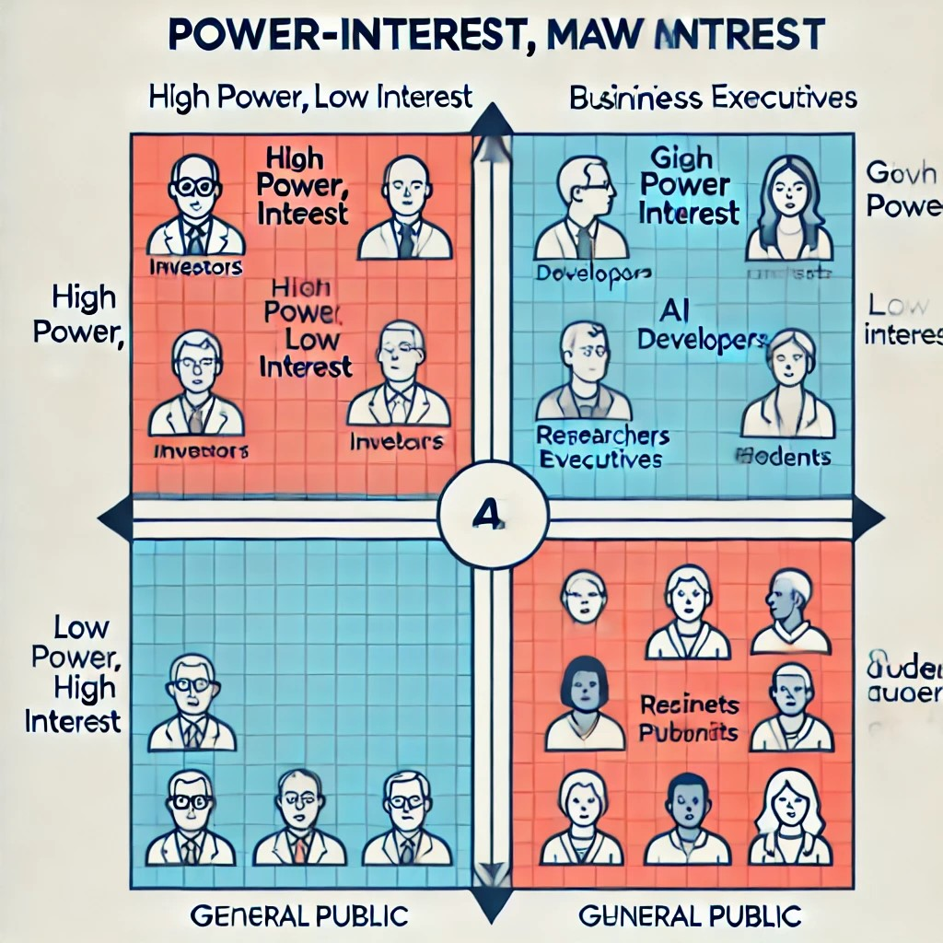

* High Power, High Interest: [Data analysts, AI developers]
* High Power, Low Interest: [Business executives]
* Low Power, High Interest: [Students, researchers]
* Low Power, Low Interest: [General public]